Precast Concrete Pavement Systems for
Rapid Pavement Repair and Replacement:
Basic Information and Commentary
(Developed by the AASHTO TIG on Precast Concrete Paving Systems, June, 2008)

Background
The durability of good concrete pavement has been demonstrated at countless installations. Long-term durability is especially important for heavily traveled roadways where maintenance, repair and reconstruction operations can disrupt traffic. Unfortunately, while very heavily traveled roadways are among the best applications for concrete pavement, traffic control issues at these sites can present great challenges for constructing traditional concrete pavements. Innovative methods of staging and traffic detours have proven effective at some locations, but they are not always effective at locations where closure times less than eight hours are desired.

Precast concrete pavement systems (PCPS) are especially useful for the rapid repair and replacement of concrete pavement. PCPS (including pre- and post-tensioned slab systems) are pre-engineered concrete pavements that are fabricated off-site and are transported to the project site for installation on a prepared foundation.
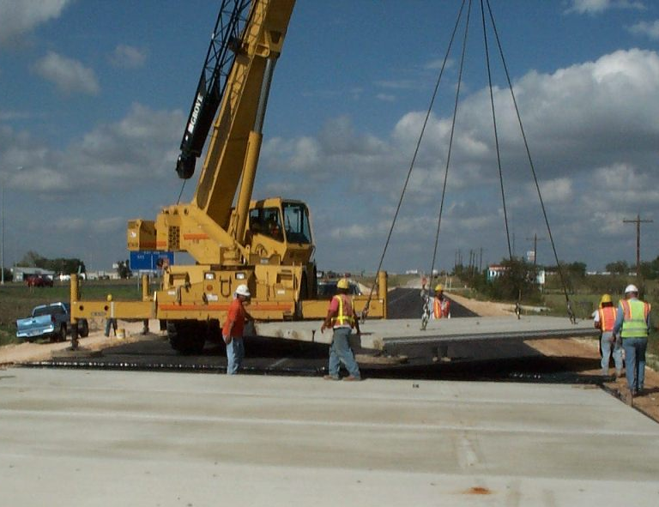
2002 Continuous installation near Georgetown, TX
2001 Continuous installation at the Tappan Zee Bridge toll plaza, Tarrytown, NY
These systems do not require field curing time to achieve strength and durability. They can often carry traffic immediately after installation. This minimizes closure times and accompanying traffic delays that may result from detouring or staging. In addition, precast slabs can be manufactured with strict control of materials and environmental conditions, which maximizes the potential for long-term durability and pavement life.

Where Can Precast Concrete Pavement Systems Be Used?
Applications of precast concrete pavement technology can generally be classified in one of two categories:

- Intermittent: intermittent repairs of existing highway and airfield concrete pavements.
- Continuous: construction or reconstruction/replacement of long segments or large areas of concrete pavement.
Best Applications for Precast Concrete Pavement Systems
Reconstruction. Reconstruction is necessary when the existing pavement is too badly deteriorated to repair cost-effectively. The designer should choose a pavement material that can serve for the desired design life and that can be installed in the desired project work window (see Table 1). Precast concrete pavement systems are most competitive when highly durable pavement is required but construction must take place in a series of very short work windows, permitting full traffic capacity during peak travel periods.

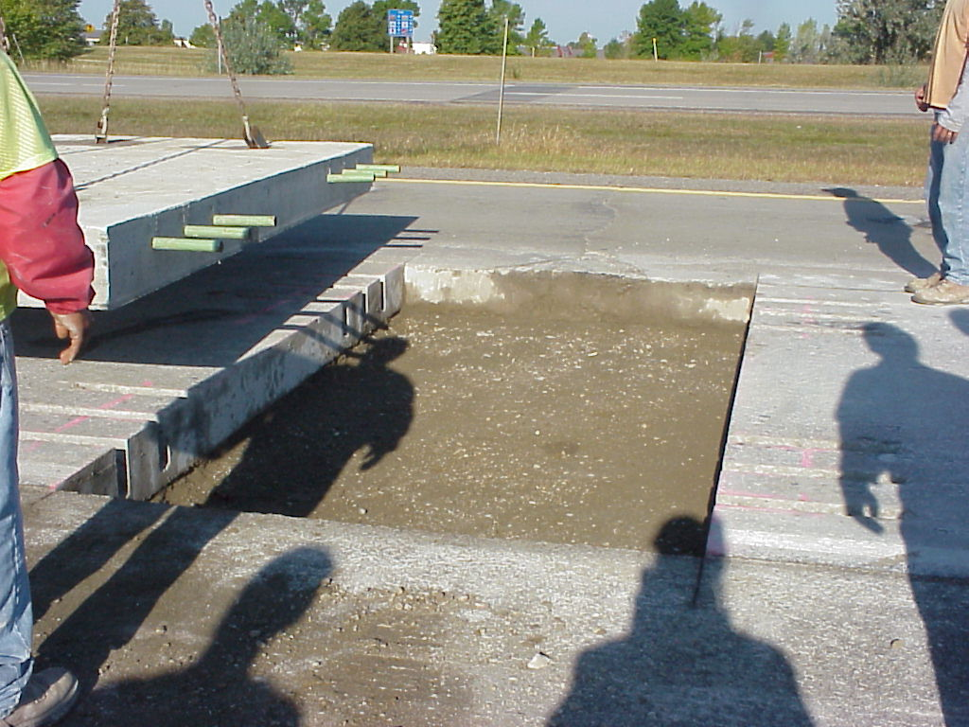
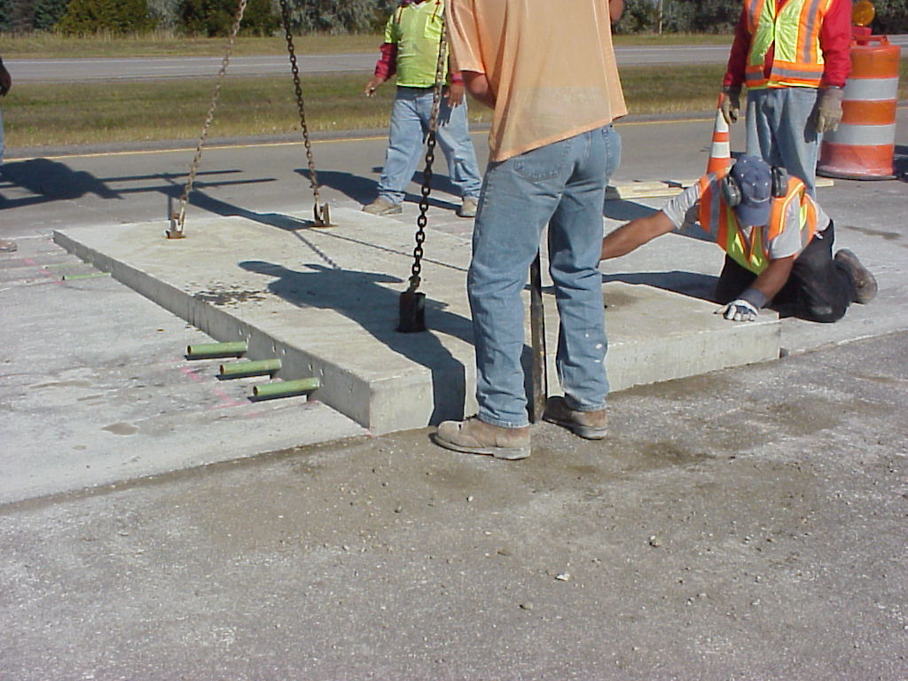
Long-term Repairs/Patches. Long-life repairs are often considered when intermittent areas of distress exist in otherwise good concrete pavement. The selection of the most suitable type of repair material often depends mainly on cost-effectiveness, but may be dictated by the desired or available work windows. Precast concrete pavement systems provide a good solution to the problem of providing durable, reliable long-term repairs in short construction windows. Table 1 summarizes the key advantages and disadvantages of several types of materials that may be considered for long-term (permanent) repairs.

Short-term Repairs/Patches. The objective of many repair projects is to provide short-term repairs in advance of a planned reconstruction. Ready-mix concrete or hot-mix asphalt are commonly used in such situations, although rapid-set materials may be considered when available work windows are short. Unfortunately, reconstruction activities are often significantly delayed (sometimes indefinitely) and the temporary repair materials deteriorate and must be replaced. This is an inefficient and costly approach that can be avoided if longer-lasting repair materials (including precast concrete panels) are used in the first place. When standards are adopted for precast repair sizes, long-life repairs can be installed and later removed for re-use on another project at the time of reconstruction.
October 2003 intermittent installation on I-675 near Detroit, MI

Available Systems
Promising precast concrete pavement systems have been developed and installed at a number of very busy sites in the United States and Canada. Full-scale installations have been achieved in five- and eight-hour work windows on several projects of different types, including mainline interstate roadways and ramps, as well as in urban intersections that include features such as crosswalks and utility access slabs. A summary of the most commonly used precast concrete pavement systems and lists of their installations sites can be found at http://tig.transportation.org/?siteid=57&pageid=1826.

Deciding to Use Precast Concrete Pavement Technology
Many considerations and factors play a role in determining whether the use of precast concrete is a good and competitive option for a particular project. The following sections provide brief commentary on some of the more important issues that may arise in the decision-making process.

Available Work Windows
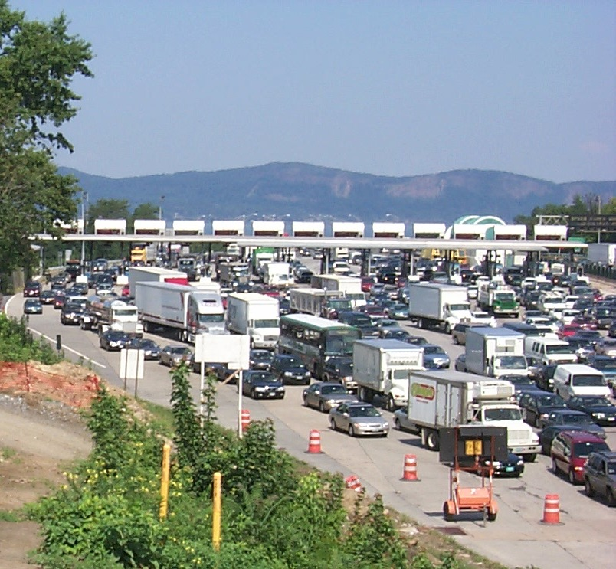
The need for a rapid repair or reconstruction project must consider traffic density and all traffic flow alternatives, recognizing that specifying short or intermittent work windows will result in extra project costs, particularly for rapid construction activities accomplished primarily during off-peak hours. If initial project budgets were established assuming conventional construction without significant time or work window constraints, additional funding will probably be required for rapid repair activities. These funds may be justifiable in terms of reduced congestion costs, user delays, worker safety and other benefits.

Once it has been decided to utilize rapid repair or reconstruction techniques, the duration of the available work window plays a major role in selecting the most appropriate repair material for rapid concrete pavement repair and construction projects.
August 2001 morning traffic congestion at the Tappan Zee Bridge toll plaza near Tarrytown, NY.

Conventional cast-in-place concrete is generally the most cost-effective material alternative when the affected lanes can be closed long enough to allow sufficient curing to produce durable pavement of adequate strength (e.g., more than 24 hours). When the work window is less than 24 hours, concretes that develop compressive strengths greater than 21 MPa [3000 psi] in 12-24 hours may be suitable and cost-effective if the construction window is long enough for slab removal, construction and curing operations and if the contractor has the experience necessary to work with and properly handle the material.

Precast concrete should be considered for all short work windows. When work windows shrink to twelve hours or less, the use of precast concrete systems becomes increasingly favored because the amount of time available may be insufficient for reliably producing properly cured and durable cast-in-place materials.

Room Required for Installation
It is generally accepted that a working width of at least two lanes (24 ft [7.3 m]) or one lane plus an adjacent shoulder (total width of 22 ft [7.0 m]) is required for precast slab installation operations and equipment. The duration of the available work window must be defined as the number of hours that this working area can be closed to traffic before it is opened up again.

Durability and Performance Life Requirements
Precast concrete slabs can offer a very high level of durability and can be produced more reliably because precast systems are fabricated under highly controlled conditions (as opposed to field conditions, which can vary greatly). This high durability is the factor that attracts agencies in search of pavement materials that will last for 50, 75 or even 100 years.

Designers should consider that the durability of the concrete slab is not the only factor that affects or controls pavement life. Structural details (e.g., transverse and longitudinal joint load transfer systems, provisions for expansion, joint seals, panel dimensions, subbase and base conditions, and drainage design) are other factors that can greatly affect long-term durability and potential pavement performance. Therefore it is necessary to evaluate all of these details, along with the durability of the concrete material, in determining the overall performance potential of each pavement system.

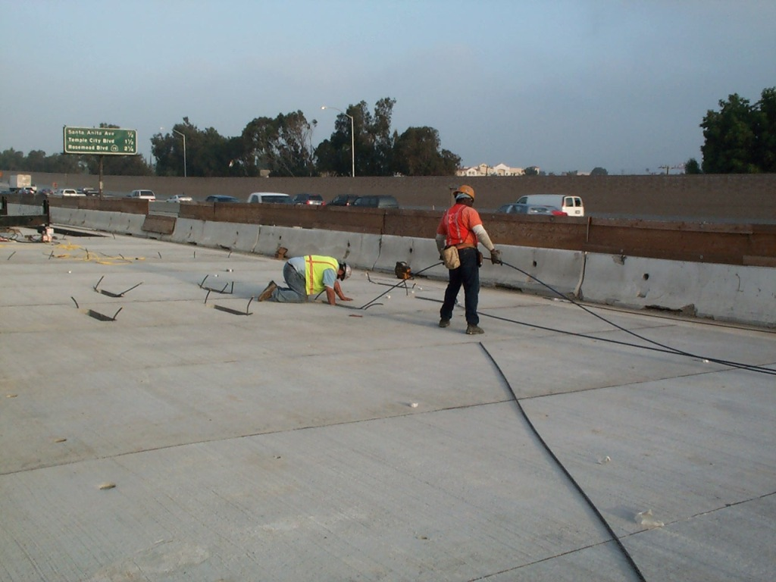
Cost Issues
Rapid repair techniques and materials are often more costly than those used for conventional construction when work windows are not significantly constrained. Historical cost data for the use of precast slabs is difficult to find because few production-scale paving projects have been constructed using precast pavement technology; many of the projects successfully completed to date have been demonstration projects, for which cost data are not representative of production paving operations. The best source for information concerning the costs and types of projects constructed to date is the AASHTO TIG Web Site at http://tig.transportation.org/?siteid=57&pageid=1826 . This information will be useful in estimating the project-specific costs of installing a precast concrete pavement system. Engineers considering the use of precast concrete pavement systems may want to directly contact the system suppliers for the latest available cost information.

After the costs of precast concrete pavement technology have been estimated for a proposed project, they can be compared with the costs of other paving materials that exhibit similar speed-of- installation and durability characteristics.

If the alternatives being considered include materials that cannot be constructed within similar time constraints or do not provide similar levels of durability and reliability, then these additional factors should be considered. Life cycle cost analyses and value engineering approaches can be used to consider not only initial agency costs, but expected future maintenance and rehabilitation costs (including traffic management costs), along with user delay costs, congestion costs, and other costs and factors. It may quickly become apparent that the use of pavement materials that can be installed quickly and can reliably provide long service life will offset higher initial costs with substantial savings in future maintenance, congestion and user costs, especially for heavily travelled urban corridors and intersections.

Use of Multiple Materials
It should also be kept in mind that more than one material can be used on a specific project. Parts of an intersection, for example, may be staged in a way that allows the use of longer work windows and conventional concrete in some parts while requiring rapid repair materials in other more critical areas.

Getting Started
When precast concrete pavement technology is selected for use, the pavement designer is faced with the challenge of determining the best system for the project. Several precast concrete slab systems are currently available, and the designer needs to determine which system(s) can be installed in the allotted work window(s), which systems feature slab connection systems that will provide the desired joint function between adjacent slabs in all directions, which bedding or slab support systems are most appropriate for site conditions, and which systems appear to have proven performance records in similar applications. The designer should also consider the capability of local precast concrete suppliers and contractors for fabricating and installing the slabs. Summaries of the features, capabilities, and available technical support for the most commonly used precast concrete pavement systems can be found in the AASHTO TIG website at http://tig.transportation.org/?siteid=57&pageid=1826.

After selecting a suitable precast concrete pavement system, it may be necessary to develop or modify specifications for the project. The AASHTO TIG website at http://tig.transportation.org/?siteid=57&pageid=1826 contains several examples of specifications from successful precast concrete pavement projects, as well as a generic specification template to help designers develop specifications that are well-suited to specific local projects.

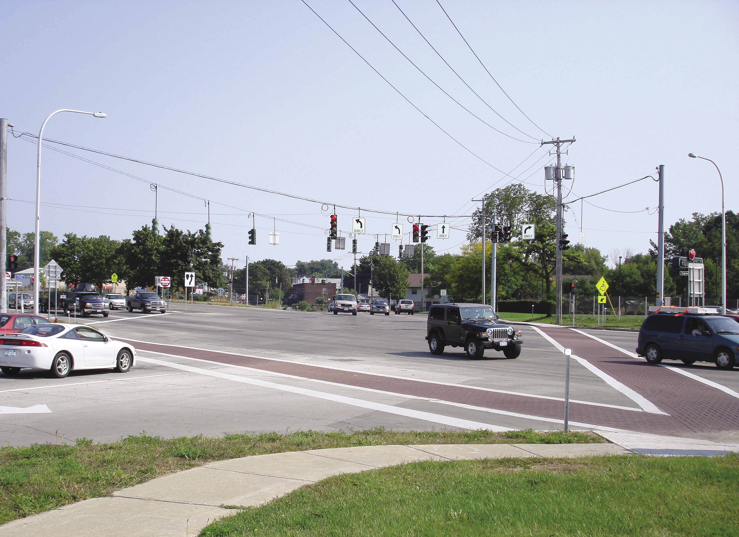
Summary
The ability to rapidly construct durable concrete pavement or concrete pavement repairs using precast concrete pavement systems has been successfully demonstrated on many projects in recent years. This opens the door to widespread implementation on numerous heavily traveled roadways where durable materials must be placed but traffic conditions necessitate short work windows that may not permit the reliable use of conventional (or even rapid strength) concrete paving materials.

While the processes of deciding to use and specifying precast concrete pavement systems can be somewhat challenging for any particular project, the AASHTO TIG website contains information, tools and example specifications that can facilitate the work and help to ensure a successful project.
2006 installation of nonplanar slabs in intersection of Rt 7 and Watt Street, Schenectady, NY

Precast concrete pavement systems should be considered to be a technology that complements conventional concrete paving, which is likely to remain highly cost-effective for most general reconstruction and repair applications on highway and airfield systems. Precast concrete pavement systems are, however, valuable tools for rapidly repairing or replacing segments of heavily trafficked highway in restricted work windows.

Table 1. Key Advantages and Disadvantages of Alternate Concrete Materials for Paving and Repair

PAVEMENT MATERIAL | PROS | CONS
Conventional Cast-in-Place Concrete | - Large amount of experience with design, materials and construction techniques.  - Applicable specifications are generally available.  - Efficient placement equipment is generally available.  - Offers the potential for being durable, long-lasting, and low-maintenance.  - Costs are usually predictable:  - Contractor familiarity and competition often results in relatively low first costs.  - Durable materials also have low life-cycle costs. | - May be difficult to construct in some traffic conditions.  - Time required for placement and proper curing may exceed available or desired construction window.  - Care must be taken to avoid excessive built-in temperature gradients (slab curling).  - Climate conditions (e.g., extreme heat, cold, wind, etc.) may limit or impact construction operations.
Concrete Requiring Cure Time of 12 - 24 hours | - Material is readily available.  - Many contractors have experience with these materials.  - Though relatively new, applicable specifications are generally available.  - Conventional placement equipment can generally be used.  - Generally offer the potential for durable and long-lasting installations.  - Costs are relatively stable and predictable. | - Some materials may be more susceptible to cracking (due to effects of higher temperatures generated during curing), resulting in shorter pavement life.  - May be more sensitive to mix, placement and curing processes, requiring closer monitoring and controls.  - Costs may be higher than for conventional concrete, particularly for fixed-form construction.
Concrete Requiring Cure Time of 4 - 12 hours) | - High early strength allows opening to traffic in 4 – 12 hours after concrete placement.  - Uses conventional placement equipment and techniques with which contractors are generally familiar. | - Suitable materials and applicable specifications may not be readily available.  - It can be difficult to develop mixtures that provide the necessary strength gain and long-term performance.  - Good experience in using these mixes is highly beneficial and may not be readily available.  - Set times can be very sensitive to mix and ambient temperature conditions and can be difficult to predict or control accurately.  - If these materials stiffen prematurely, there may be difficulties with mixing, placement, screeding and /or finishing. A larger work force may be necessary.  - Some agencies have noted durability problems with these materials.  - Initial costs are often much higher than for conventional concrete.  - Higher first costs and shorter service life can lead to very high life-cycle costs.
Precast Concrete Pavement Systems | - No field cure time required for slab concrete – traffic can be carried immediately after placement.  - Slabs are fabricated and cured under controlled conditions, providing the potential for excellent durability and long service life.  - Control of curing conditions can virtually eliminate early-age cracking.  - High assurance that lanes will be opened to traffic on time because slabs are ready for traffic as soon as they are installed  - Since there is no finishing or formwork, placement requires only small crews.  - Slab installation activities are not greatly affected by weather conditions; construction can be accomplished in very hot, cold or rainy conditions without impacting slab performance or durability.  - Experience shows that short sections of precast concrete pavement can be installed in work windows of 5 hours or less.  - The potential for rapid installation and long pavement life minimizes short- and long-term user delay costs.  - Expected long pavement life and lower user costs can offset higher initial costs in life-cycle cost analyses. | - Many contractors lack experience with precast paving slab installation. They may require training and/or experience.  - Some precast paving systems may require special equipment and/or techniques for preparing the subgrade and/or for installing the bedding material.  - The life of some materials used to achieve joint load transfer may be sensitive to preparation and installation procedures. Manufacturer’s directions must be strictly followed.  - Precast slabs may vary slightly in thickness (as allowed by fabrication tolerances), resulting in slight variations in the pavement surface. Unacceptable variations may require removal by diamond grinding.  - Initial costs for precast concrete pavement systems can be substantially higher than for conventional concrete, although these may be offset by lower user costs and longer pavement life.

